The title written briefly and clearly, and must show precisely the problem to be raised, not to provide a variety of interpretive opportunities, not to contain abbreviations that are not commonly used, not too long (no more than 15 words), font size 14pt

¹Author name, ² Author name, etc (12pt Bold, Full name without academic degrees and titles)

Biology Education Department, Faculty of Mathematics and Science Education, IKIP Mataram. Jl. Pemuda No. 59A, Mataram, Indonesia. Postal code: 83125 (10pt Normal. The author name should be accompanied by complete affiliation address)

*Corresponding Author e-mail: abc@edu.ac.id (10pt normal)

Received: Month Year; Revised: Month Year; Published: Month Year
Abstract
The abstract is written in italics (Italic) along 150-250 words with a font size of 10 pt and Book Antiqua fonts and the distance between single-spaced lines. If the article is in Indonesian, then the abstract must be written in Indonesian and English that is good and correct. If the article is in English, the abstract must be written in English only. The Abstract section must contain the core issues to be raised, the method of solving them, and the scientific findings obtained and conclusions. Abstracts for each language can only be written in one paragraph in a single column format.

Keywords: writing instructions; e-saintika; article template (3-6 keywords)
How to Cite: First author., Second author., &amp; Third author. (20xx). The title. Jurnal Penelitian dan Pengkajian Ilmu Pendidikan: e-Saintika, vol(no), xx-xx. doi:https://doi.org/10.36312/e-saintika.vxix.xxx

https://doi.org/10.36312/e-saintika.vxix.xxx | Copyright© xxxx, First Author et al  This is an open-access article under the CC-BY-SA License.

INTRODUCTION
The introduction section must present at least four paragraphs. The first paragraph contains the general context/background related to the dependent/response/observed variables of the study (200-250 words/more). In the first paragraph, the author must describe the domain, field, or phenomenon related to the research topic/variable.
The second paragraph contains a description of the research problems (Problem Statements) containing 200-250 words or more. Research problems of scientific articles must consistently describe the title of the article/the main idea of ??the research underpinned by empirical and theoretical literature reviews. Research problems are presented in the form of research urgency reviews in the perspective of how similar problems are solved in different places. The research problem at least describes the answer to the question "why is the study important?" and “why did the problem occur and can it be resolved?”.
The third paragraph contains novelty/gaps related to the variables studied. In this paragraph the author must comprehensively describe the novelty/differences of the study conducted with the research results that already existed or has been described in the second paragraph. Research novelty, for example, can be in the form of components/indicators studied that are different from previous studies, treatments/modification of treatments, or research subjects/samples. Writers must state the novelty/gap clearly (200-250 words/more). In the novelty/gap description, the author must convey what is not yet known/researched based on the literature review/results of relevant previous studies.
The fourth/last paragraph contains the research objectives and scope/limitations of the study. The author must describe the research objectives comprehensively. The indicators of the variables studied must be stated clearly based on relevant references (200-250 words or more). The last paragraph in the introduction describes the focus and scope of the research which gives rise to an overview of the description in the previous paragraph to help the writer formulate a hypothesis. Completely, the arrangement of the introductory sections is shown in Figure 1.
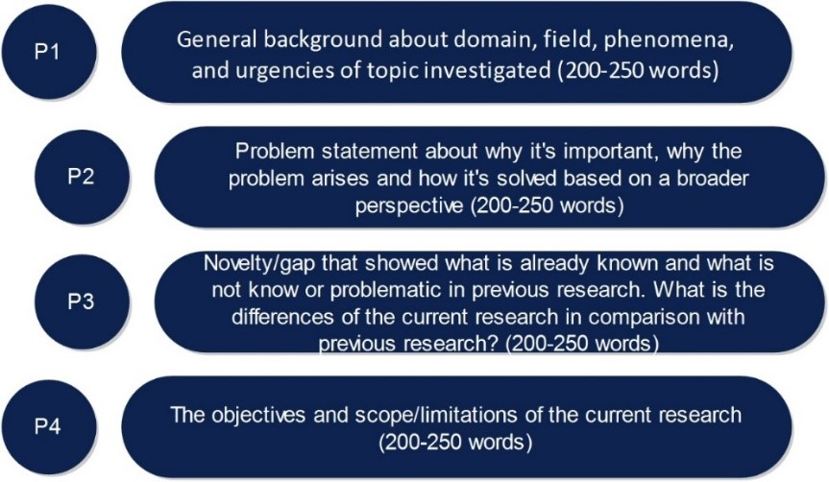
Figure 1. Content arrangement of the introduction part

METHOD
The method section contains at least four paragraphs or sub-sections. The first paragraph/subsection contains the general background covering the type of the study and the research design applied. In this part, the author must include pictures or tables to further clarify the type/design of the research used (200-250 words/more). The use of new types or research methods must be supported by an adequate reference in the form of an explanation of the specific context of the study being conducted.
Table 1. Description
Ability Type | Criteria
Ability Type | Very good | Good | Not good
Communication
Collaboration
Critical thinking
Creative Thinking
Heading 2
The second paragraph/sub-section contains the sample/research subject. In this part, the author must clearly state the number of samples/subjects involved. Thus, techniques for selecting/determining the sample and descriptions related to the characteristics of the sample/research subjects must be explained in this section (200-250 words/more).
Heading 3
The third paragraph/sub-section contains instruments and procedures (200-250 words/more). The author must describe the type, validity, and reliability of the instrument used. If the instrument is an instrument developed by another writer/researcher, the reference should be mentioned. However, if the research instrument is an instrument developed by the writer/researcher himself, the author must explain how the mechanisms are for developing, validating, and testing the reliability of the instrument used to collect research data. In addition, the research procedure covering how the research was carried out and the data are obtained, must be stated in this section. The research procedure is described based on the type of study applied.
Heading 4
The fourth/last paragraph/sub-section presents the analysis of the data used to interpret the research data that has been collected and its relation to the problems and research objectives, needs to be explained clearly (200-250 words/more). Data analysis can be quantitative using statistical techniques or qualitative using codes and content analysis. Data analysis techniques and criteria for interpreting research data must be presented clearly based on reviews of relevant empirical or theoretical studies. Shortly, the arrangement of the results and discussion sections is shown in Figure 2.
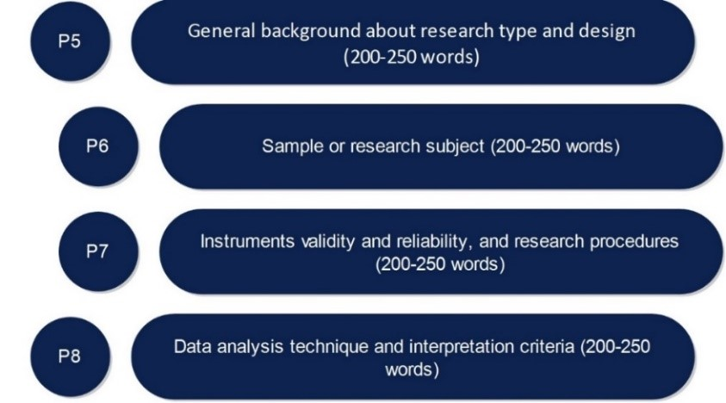
Figure 2. Contents of the research method

RESULTS AND DISCUSSION
This part must state at least four crucial points. Each point consists of two paragraphs containing a description of the research findings (empirical findings) and why/how these findings occurred/obtained (rationality) (200-250 words/more). The results present research findings obtained through a series of procedures that have been stated in the research methods. The results must be presented briefly and clearly so that it is easy for readers to understand. Research results can be also often presented in tabular form of statistical analysis results and illustrative pictures of research findings.
The next paragraph contains empirical and/or theoretical support relevant to the research findings obtained (empirical and theoretical support) from references to reputable journal articles (200-250 words or more). If the research findings are similar to the results of previous studies (empirical and theoretical support), the author must describe the location of these similarities. If the findings are different, the author must also elaborate the location of these differences and why differences in research findings may occur accompanied by scientific arguments based on empirical references. In addition to the comparative description of research findings with previous studies, the author must discuss the research weaknesses that have implications for research results in this section. Simply, the arrangement of the results and discussion sections is shown in Figure 3.
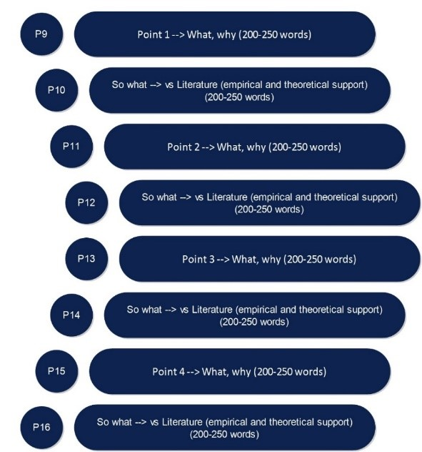
Figure 3. The content parts of the results and discussion

CONCLUSION
The Conclusion part describes the answers to the hypotheses and/or research objectives or scientific findings obtained. The conclusion does not contain a repetition of the results and discussion, but rather summarizes the findings as expected in the objectives or hypotheses. In addition, implications, significance of research results, and recommendations for further studies are also presented in this section.

RECOMMENDATION
Recommendations describe things that will be done related to the next idea of the research. Barriers or problems that can influence the results of the research are also presented in this section.
Acknowledgments (if applicable-Mandatory for AI disclosure) (10 PT)
This section should acknowledge individuals who provided personal assistance to the work but do not meet the criteria for authorship, detailing their contributions. It is imperative to obtain consent from all individuals listed in the acknowledgments.
Authors must fully disclose the use of AI tools in their manuscript submissions. This includes, but is not limited to, tools used for text generation, image creation, data analysis, coding assistance, or translation. The disclosure should be placed in the Acknowledgements section of the manuscript and should specify the name of the AI tool, the version used, and the purpose of its application. For the detailed instruction, please visit: https://journal-center.litpam.com/index.php/e-Saintika/ai-policies
Funding Information (mandatory) (10 PT)
Please add: “This research received no external funding” if there is no funding involved or “This research was funded by NAME OF FUNDER, grant number XXX” and “The APC was funded by XXX”.
Author Contributions Statement (mandatory) (10 PT)
This journal uses the Contributor Roles Taxonomy (CRediT) to recognize individual author contributions, reduce authorship disputes, and facilitate collaboration. The recommended number of authors is at least two, with one of them designated as the corresponding author. The corresponding author will be responsible for all correspondence related to the paper and must ensure that the other authors are included in the communication regarding submission, revision, and publication processes. We encourage authors to include a statement in the paper that shares and accurately describes each author's contribution. To be eligible for authorship, each individual must have contributed to at least one of the following: conceptualization, methodology, formal analysis, or investigation, as well as at least one aspect of writing (either original draft preparation or writing reviews and editing).
Name of Author | C | M | So | Va | Fo | I | R | D | O | E | Vi | Su | P | Fu
Author 1 name
Author 2 name
Author 3 name
…..
Author x name

C : Conceptualization  M : Methodology  So : Software  Va : Validation  Fo : Formal analysis | I : Investigation  R : Resources  D : Data Curation  O : Writing - Original Draft  E : Writing - Review & Editing | Vi : Visualization  Su : Supervision  P : Project administration  Fu : Funding acquisition
See the examples below:
Name of Author | C | M | So | Va | Fo | I | R | D | O | E | Vi | Su | P | Fu
Faizul Bayani
Joni Rokhmat
Aliefman Hakim
AA Sukarso
Conflict Of Interest Statement (mandatory) (10 PT)
To ensure fair and objective decision-making, authors must declare any associations that pose a conflict of interest (financial, personal, or professional) in connection with manuscripts. Non-financial competing interests include a declaration of political, personal, religious, ideological, academic, and intellectual competing interests. The authors declare that they have no known competing financial interests or personal relationships that could have appeared to influence the work reported in this paper. If there are no conflicts of interest, please include the following author's statement: Authors state no conflict of interest.
Informed Consent (if applicable) (10 PT)
The protection of privacy is a legal right that must not be breached without individual informed consent. In cases where the identification of personal information is necessary for scientific reasons, authors should obtain full documentation of informed consent, including written permission from the patient prior to inclusion in the study. Incorporate the following (or a similar) statement: We have obtained informed consent from all individuals included in this study.
Ethical Approval (if applicable) (10 PT)
When papers talk about using people or animals, authors should make it clear that the research followed all national rules and institutional policies, and it was approved by the authors' institutional review board or a similar committee. The Helsinki Declaration's tenets must guide all investigations involving human subjects. Authors must also identify the committee or review board approving the experiments and provide a statement indicating approval of the research. Incorporate the following (or a similar) statement: The research related to human use has been complied with all the relevant national regulations and institutional policies in accordance with the tenets of the Helsinki Declaration and has been approved by the authors' institutional review board or equivalent committee; or: The research related to animal use has been complied with all the relevant national regulations and institutional policies for the care and use of animals.
Data Availability (mandatory) (10 PT)
The data availability statement is a valuable link between a paper’s results and the supporting evidence. It is a brief statement about whether the authors of an article have made the evidence supporting their findings available, and if so, where readers may access it. Data availability statements help to promote transparency and reproducibility in research and to increase the visibility of valuable evidence produced or gathered during the course of research. As part of our commitment to supporting open research, our journal now requires all manuscripts to include a data availability statement in order to be accepted for publication. Examples:
- The data that support the findings of this study are openly available in [repository name] at http://doi.org/[doi], reference number [reference number].
- The data that support the findings of this study will be available in [repository name] [URL / DOI link] following a [6 month] embargo from the date of publication to allow for the commercialization of research findings.
- The data that support the findings of this study are available on request from the corresponding author, [initials, AB]. The data, which contain information that could compromise the privacy of research participants, are not publicly available due to certain restrictions.
- Derived data supporting the findings of this study are available from the corresponding author [initials, AB] on request.
- The data that support the findings of this study are available from [third party]. Restrictions apply to the availability of these data, which were used under license for this study. Data are available [from the authors / at URL] with the permission of [third party].
- The authors confirm that the data supporting the findings of this study are available within the article [and/or its supplementary materials].
- The data that support the findings of this study are available from the corresponding author, [initials, AB], upon reasonable request.
Data availability is not applicable to this paper as no new data were created or analyzed in this study.

REFERENCES
All references referred to in the text of the article must be registered in the References section. The bibliography must contain reference libraries originating from primary sources (scientific journals and amounting to a minimum of 80% of the total bibliography) published in the last 10 (ten) years. Each article contains at least 25-30 references. Writing a referral system in an article text and writing a bibliography should use a reference management application program, for example, Mendeley, EndNote, or Zotero, or others.
Guide to Writing References
Writing references should use reference management applications such as Mendeley, EndNote, Zotero, or others. The format of writing used in the e-Saintika is in accordance with the format of the APA (American Psychological Association).
- Journal articles: Bekker, J. G., Craig, I. K., & Pistorius, P. C. (1999). Modeling and Simulation of Arc Furnace Process. ISIJ International, 39(1), 23–32. doi/url
- Book: Fridman, A. (2008). Plasma Chemistry. Cambridge: Cambridge University Press.
- Articles in proceedings: Roeva, O. (2012). Real-World Applications of Genetic Algorithm. In International Conference on Chemical and Material Engineering (pp. 25–30). Semarang, Indonesia: Department of Chemical Engineering, Diponegoro University.
- Thesis and dissertation, research reports: Istadi, I. (2006). Development of A Hybrid Artificial Neural Network – Genetic Algorithm for Modelling and Optimization of Dielectric-Barrier Discharge Plasma Reactor. PhD Thesis. Universiti Teknologi Malaysia.
- Chapter in an edited book: Hovmand, S. (1995). Fluidized Bed Drying. In Mujumdar, A.S. (Ed.) Handbook of Industrial Drying (pp.195-248). 2nd Ed. New York: Marcel Dekker.
- Website: United Arab Emirates architecture. (n.d.). Retrieved June 17, 2010, from UAE Interact website: http://www. uaeinteract.com/
- Articles from the websites: Benton Foundation. (1998, July 7). Barriers to closing the gap. In Losing ground bit by bit: Low-income communities in the information age (chap. 2). Retrieved from http://www.benton.org/library?low-Income/two.html

