Title: The title of the scientific article must describe the objectives and the approach used to achieve the research objectives
Author Fullname ¹, Author Fullname ^{2,}*, etc
- Affiliation
- Affiliation
- etc
*Correspondence: correspondingauthor@email.com
Abstract
The abstract section must contain (1) the core issues to be raised (the main research problem, the factors that make the research interesting and important to do), (2) the research objectives (what is to be achieved, the gaps to be filled/accommodated), (3) the method of completion (experimental, theoretical, or mixed methods, procedures and analyzes carried out to achieve the research objectives), (4) scientific findings (main research findings supported by quantitative data if any), and (5) conclusions/implications (main conclusions of the research, why it is crucial and the implications of research results are presented in this section).
Keywords: Writing instructions; IJCE journal; Article template
INTRODUCTION
The introductory section contains at least four paragraphs. The first paragraph includes the general context/background related to the dependent variable/response/observed from the research (200-250 words). In the first paragraph, the author must describe the domain, field, or phenomenon related to the topic/variable being studied.
The second paragraph describes the research problem in 200-250 words. Research problems are presented based on (1) the research urgency and (2) how similar problems are solved in different places. To demonstrate this, the authors should refer to articles from reputable international journals (especially journals for publication) to show a broader perspective regarding the context of the proposed research problem. The research problem at least describes the answer to the question "why is this research important?" and “why did the problem occur, and can it be solved?”.
The third paragraph contains the novelty/gap related to the variables studied. In this paragraph, the author must comprehensively describe the novelty/difference of the research conducted with the results of existing research or have been described in the second paragraph. For example, the novelty of the research can be in the form of components/indicators under study that are different from previous research, treatment/modification of treatment, or research subjects/samples. The author must clearly state the novelty/gap (200-250 words).
The fourth/last paragraph contains the research's objectives and scope/limitations. The author must describe the research objectives comprehensively. The variables' indicators must be presented clearly based on relevant references (200-250 words). The last paragraph in the introduction describes the focus and scope of the research, which gives rise to the description in the previous paragraph to help the writer formulate a hypothesis. In addition, this paragraph serves as a reflection of the discussion of research results. In simple terms, the composition of the introduction is shown in Figure 1.
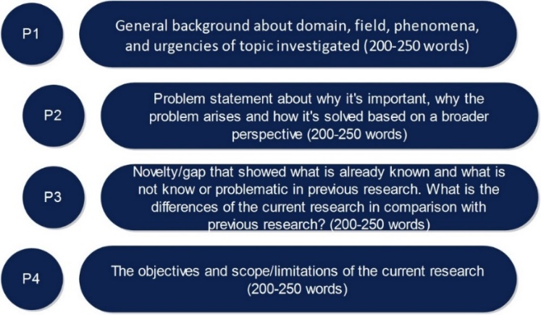
Figure 1. The composition of the introduction contents
METHOD
The methods section also contains at least four paragraphs or subsections. The first paragraph/sub-section includes the general background, which consists of the research type and design used. In this section, the author can consist of pictures or tables to clarify further the type/design of the research used (200-250 words). Research designs and methods must be clearly described because often, the reader will go directly to this section.
Sub-Heading 1
The second paragraph/sub-section contains the sample/subject of the research. The author must clearly state how many samples/subjects are used in this section. Sample selection/determination techniques and descriptions related to the characteristics of the sample/research subject must also be described in this section (200-250 words).
Sub-Heading 2
The third paragraph/sub-section contains instruments and procedures (200-250 words). The author must describe the instrument's type, validity, and reliability. If the instrument used is an instrument that has been developed by other authors/researchers, then include the references used. However, suppose the author/researcher himself develops the research instrument. In that case, it must be explained how the mechanism for developing, validating, and testing the reliability of the instrument used to collect research data. In addition, the research procedure, which includes how the research was conducted and the data obtained, should be described in this section. The research procedure is described based on the type of research used.
Sub-Heading 3
The fourth/last paragraph/sub-section contains data analysis used to interpret the research data that has been collected and its relation to the problems and research objectives, which need to be explained clearly (200-250 words). Data analysis can be quantitative using statistical techniques or qualitative using codes and content analysis. Data analysis techniques and criteria for interpreting research data must be presented based on a review of relevant empirical or theoretical studies. In simple terms, the arrangement of the results and discussion sections is shown in Figure 2.
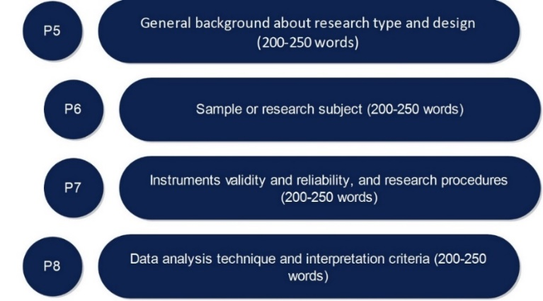
Figure 2. The composition of the contents of the method section
RESULTS AND DISCUSSION
This section contains at least four points. Each point consists of two paragraphs describing the research findings (empirical finding) and why/how these findings can occur/obtained (rationality; 200-250 words). The research results contain findings obtained through a series of procedures described in the research methods section. Research results must be presented briefly and clearly so that it is easy for readers to understand. Research results are also often presented in tabular form in the form of statistical analysis results and illustrations of research findings.
Table 1. Description
Ability Type | Criteria
Ability Type | Very good | Good | Not good
Communication
Collaboration
Critical thinking
Creative Thinking
The following paragraph contains empirical and theoretical support relevant to the research results obtained from references to reputable scientific journal articles (200-250 words). If the research findings are similar to the results of previous studies (empirical and theoretical support), the author must describe the location of the similarities. If the findings differ, the authors must also describe the perspectives and why differences in research findings can occur with scientific arguments based on adequate empirical references. In simple terms, the arrangement of the results and discussion sections is shown in Figure 3.
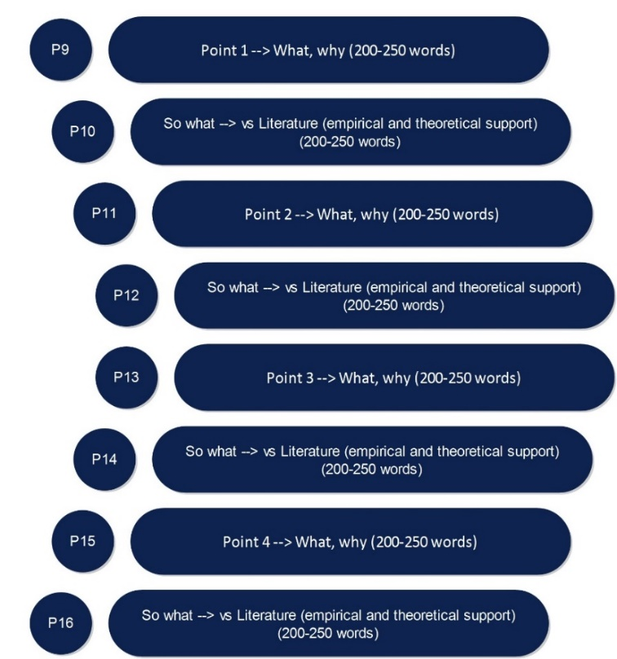
Figure 3. The composition of the results and discussion section contents
CONCLUSION
Conclusions describe answers to hypotheses or research objectives, or scientific findings obtained. The conclusion summarizes the findings as expected in the objectives or hypotheses, not a repetition of the results and discussion.
RECOMMENDATION
In addition, the implications, significance of the research results, and recommendations for further research presented in this section.
Acknowledgments (if applicable-Mandatory for AI disclosure) (10 PT)
This section should acknowledge individuals who provided personal assistance to the work but do not meet the criteria for authorship, detailing their contributions. It is imperative to obtain consent from all individuals listed in the acknowledgments.
Authors must fully disclose the use of AI tools in their manuscript submissions. This includes, but is not limited to, tools used for text generation, image creation, data analysis, coding assistance, or translation. The disclosure should be placed in the Acknowledgements section of the manuscript and should specify the name of the AI tool, the version used, and the purpose of its application. For the detailed instruction, please visit: https://journal-center.litpam.com/index.php/ijece/ai-policies
Funding Information (mandatory) (10 PT)
Please add: “This research received no external funding” if there is no funding involved or “This research was funded by NAME OF FUNDER, grant number XXX” and “The APC was funded by XXX”.
Author Contributions Statement (mandatory) (10 PT)
This journal uses the Contributor Roles Taxonomy (CRediT) to recognize individual author contributions, reduce authorship disputes, and facilitate collaboration. The recommended number of authors is at least two, with one of them designated as the corresponding author. The corresponding author will be responsible for all correspondence related to the paper and must ensure that the other authors are included in the communication regarding submission, revision, and publication processes. We encourage authors to include a statement in the paper that shares and accurately describes each author's contribution. To be eligible for authorship, each individual must have contributed to at least one of the following: conceptualization, methodology, formal analysis, or investigation, as well as at least one aspect of writing (either original draft preparation or writing reviews and editing).
Name of Author | C | M | So | Va | Fo | I | R | D | O | E | Vi | Su | P | Fu
Author 1 name
Author 2 name
Author 3 name
…..
Author x name

C : Conceptualization  M : Methodology  So : Software  Va : Validation  Fo : Formal analysis | I : Investigation  R : Resources  D : Data Curation  O : Writing - Original Draft  E : Writing - Review & Editing | Vi : Visualization  Su : Supervision  P : Project administration  Fu : Funding acquisition
See the examples below:
Name of Author | C | M | So | Va | Fo | I | R | D | O | E | Vi | Su | P | Fu
Faizul Bayani
Joni Rokhmat
Aliefman Hakim
AA Sukarso
Conflict of Interest Statement (mandatory) (10 PT)
To ensure fair and objective decision-making, authors must declare any associations that pose a conflict of interest (financial, personal, or professional) in connection with manuscripts. Non-financial competing interests include a declaration of political, personal, religious, ideological, academic, and intellectual competing interests. The authors declare that they have no known competing financial interests or personal relationships that could have appeared to influence the work reported in this paper. If there are no conflicts of interest, please include the following author's statement: Authors state no conflict of interest.
Informed Consent (if applicable) (10 PT)
The protection of privacy is a legal right that must not be breached without individual informed consent. In cases where the identification of personal information is necessary for scientific reasons, authors should obtain full documentation of informed consent, including written permission from the patient prior to inclusion in the study. Incorporate the following (or a similar) statement: We have obtained informed consent from all individuals included in this study.
Ethical Approval (if applicable) (10 PT)
When papers talk about using people or animals, authors should make it clear that the research followed all national rules and institutional policies, and it was approved by the authors' institutional review board or a similar committee. The Helsinki Declaration's tenets must guide all investigations involving human subjects. Authors must also identify the committee or review board approving the experiments and provide a statement indicating approval of the research. Incorporate the following (or a similar) statement: The research related to human use has been complied with all the relevant national regulations and institutional policies in accordance with the tenets of the Helsinki Declaration and has been approved by the authors' institutional review board or equivalent committee; or: The research related to animal use has been complied with all the relevant national regulations and institutional policies for the care and use of animals.
Data Availability (mandatory) (10 PT)
The data availability statement is a valuable link between a paper’s results and the supporting evidence. It is a brief statement about whether the authors of an article have made the evidence supporting their findings available, and if so, where readers may access it. Data availability statements help to promote transparency and reproducibility in research and to increase the visibility of valuable evidence produced or gathered during the course of research. As part of our commitment to supporting open research, our journal now requires all manuscripts to include a data availability statement in order to be accepted for publication. Examples:
- The data that support the findings of this study are openly available in [repository name] at http://doi.org/[doi], reference number [reference number].
- The data that support the findings of this study will be available in [repository name] [URL / DOI link] following a [6 month] embargo from the date of publication to allow for the commercialization of research findings.
- The data that support the findings of this study are available on request from the corresponding author, [initials, AB]. The data, which contain information that could compromise the privacy of research participants, are not publicly available due to certain restrictions.
- Derived data supporting the findings of this study are available from the corresponding author [initials, AB] on request.
- The data that support the findings of this study are available from [third party]. Restrictions apply to the availability of these data, which were used under license for this study. Data are available [from the authors / at URL] with the permission of [third party].
- The authors confirm that the data supporting the findings of this study are available within the article [and/or its supplementary materials].
- The data that support the findings of this study are available from the corresponding author, [initials, AB], upon reasonable request.
- Data availability is not applicable to this paper as no new data were created or analyzed in this study.
REFERENCES
All references referred to in the text of the article must be registered in the References section. The bibliography must contain reference libraries originating from primary sources (scientific journals and amounting to a minimum of 80% of the total bibliography) published in the last 10 (ten) years. Writing a referral system in an article text and writing a bibliography should use a reference management application program, for example, Mendeley, EndNote, Zotero, or others.
Guide to Writing References
Writing references should use reference management applications such as Mendeley, End Note, Zotero, or others. The format of writing used in the IJECE (International Journal of Essential Competencies in Education) is in accordance with the APA 7th Edition style.

- Book: Arends, R. (2012). Learning to teach (9th ed). McGraw-Hill.
- Journal Article: Asy’ari, M., Ikhsan, M., & Muhali, M. (2019). The Effectiveness of Inquiry Learning Model in Improving Prospective Teachers’ Metacognition Knowledge and Metacognition Awareness. International Journal of Instruction, 12(2), 455–470. https://doi.org/10.29333/iji.2019.12229a
- Articles in proceedings: Roeva, O. (2012). Real-World Applications of Genetic Algorithm. In International Conference on Chemical and Material Engineering (pp. 25–30). Semarang, Indonesia: Department of Chemical Engineering, Diponegoro University.
- Thesis and dissertation, research reports: Istadi, I. (2006). Development of A Hybrid Artificial Neural Network – Genetic Algorithm for Modelling and Optimization of Dielectric-Barrier Discharge Plasma Reactor. PhD Thesis. Universiti Teknologi Malaysia.
- Chapter in edited book: Hovmand, S. (1995). Fluidized Bed Drying. In Mujumdar, A.S. (Ed.) Handbook of Industrial Drying (pp.195-248). 2nd Ed. New York: Marcel Dekker.
- Website: United Arab Emirates architecture. (n.d.). Retrieved June 17, 2010, from UAE Interact website: http://www. uaeinteract.com/
- Articles from the websites: Benton Foundation. (1998, July 7). Barriers to closing the gap. In Losing ground bit by bit: Low-income communities in the information age (chap. 2). Retrieved from http://www.benton.org/library?low-Income/two.html

